**Introduction to Data Analytics**

**Lab report #01**



Fall 2022

CSE-408L Data Analytics

Submitted by: **Ashfaq Ahmad**

Registration No: **19PWCSE1795**

Class Section: **B**

“On my honor, as student of University of Engineering and Technology, I have neither given nor received unauthorized assistance on this academic work.”

Student Signature: ______________

Submitted to:

**Eng: Faizullah**

**Oct** 29, 2022

**Department of Computer Systems Engineering**

**University of Engineering and Technology, Peshawar**

**Data Analytics:**

* Data analytics is the science of analyzing raw data to make conclusions about that information.
* The scientific process of transforming raw data into insights for making better decisions.

**Steps involves in data analysis:**

https://careerfoundry.com/en/blog/data-analytics/the-data-analysis-process-step-by-step/

**Types of Data Analytics or analysis**

Data analytics is broken down into four basic types.

1. **Descriptive analytics:**This describes what has happened over a given period of time. Have the number of views gone up? Are sales stronger this month than last?
2. **Diagnostic analytics:**This describes why something happened. Did the weather affect beer sales? Did that latest marketing campaign or advertisement impact sales?
3. **Predictive analytics:**This describes what will happen in the future. what happened to sales the last time we had a hot summer? How many weather models predict a hot summer this year?
4. **Prescriptive analytics:** This describe how can we make it happen. If the likelihood of a hot summer is measured as an average of these five weather models is above 58%, we should add an evening shift to the brewery and rent an additional tank to increase output.

**Data Science Vs Data Analytics:**

* Data Science is an umbrella that encompasses Data Analytics.
* A data analyst analyzes existing data, while data scientists create new ways of capturing and analyzing data for analysts to utilize.
* Data Science is a combination of multiple disciplines – Mathematics, Statistics, Computer Science, Information Science, Machine Learning, and Artificial Intelligence.
* On the other hand, data analytics is mainly concerned with Statistics, Mathematics, and Statistical Analysis.
* Data Science seeks to discover new and unique questions that can drive business innovation. In contrast, Data Analysis aims to find solutions to these questions and determine how they can be implemented within an organization to foster data-driven innovation.

**Data analytics vs Data analysis**

* Same things but data analytics deal with future data events while data analysis deals with past data and events.

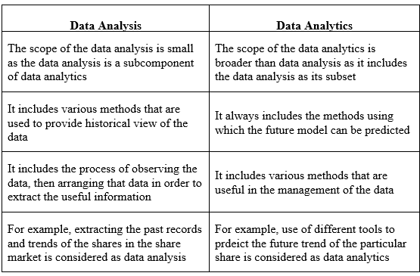

**Task**

Consider an example of your choice (like the CMS example discussed in the lab, you can take your FYP as an example). How would you apply the steps of data analytics mentioned above? Also mention, which kind of analysis from the above mentioned, can be performed for your example.

**Suppose I am taking CMS example:**

Steps of data analysis:

* 1. **Define your objective or Problem Statement :**

How to optimize the hostel’s internet service?

This is the problem statement faced by CMS that a lot of students are using hotspot due to which the quality of internet downs.

* 1. **Data collection:**

Once we’ve established our objective, we’ll need to create a strategy for collecting and aggregating the appropriate data. A key part of this is determining which data we need. This might be quantitative (numeric) data, e.g. no of students, no of routers, or qualitative (descriptive), such as weather, internet device’s quality etc.

* 1. **Data Cleaning:**

Once you’ve collected your data, the next step is to get it ready for analysis. This means cleaning, or ‘scrubbing’ it, and is crucial in making sure that you’re working with high data quality. Key data cleaning tasks include.

* Removing major errors, duplicates, and outliers:
* Removing unwanted data points
* Bringing structure to your data
  1. **Analyzing Data:**

Finally, we’ve cleaned our data. Now comes the fun bit—analyzing it! The type of data analysis we carry out largely depends on what our goal is. As our goal is related to future so we will use prescriptive analysis.

Prescriptive analysis tells us how to make targeted output possible in future.

* 1. **Deployment :**

Finally we will deploy the result of analysis.

The End